TFS #92363

CW39 & CW43: Ability to Edit Loan Position from Collateral Analysis Screen

Overview

Kevin Geissler

9/7/2016

Table of Contents

TFS # 1

Description 2

Testing Notes 2

Screen Shots and Steps Taken 2

# Description

BCM 8/5/16 - Original Request: "I’m not sure why it is a requirement for security documents to be linked to collateral when setting loan position since the security document doesn’t play into the loan position. I understand the need for it when setting lien position but FCE doesn’t use that. We also want the ability to set loan position on the collateral analysis screen (already on the enhancement list) and security documents are not on that screen either which is another reason for security documents to not be a requirement for loan position."

FPI Notes/Examples: If lien position is configurable and turned off, then can edit this…otherwise, you should not be able to edit from the collateral analysis screen.

RJM 8/8/16 - This was item #39 & #43 from the Collateral Web Enhancements list.

Linked to item #29.

From Bob's comments to EPC:

Rationalization: Productivity concerns, lots of rekeying, causes some service now cases to be created impacting FPI staff as well

Designed Solution: Fix so Lien Position is not defaulted and also display loan position in the Collateral Analysis grid since it is an attribute of the loan to collateral relationship

# Testing Notes

## Screen Shots and Steps Taken

In a **Farm Credit East** scenario on the Collateral Analysis grid, hovering over now displays an “Update Relationship” button.

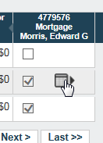

Click the button to set loan position.

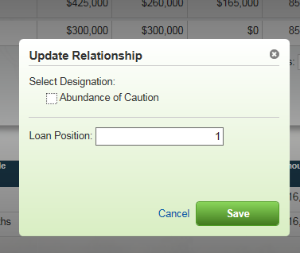

In a Yankee secenario, the “Update Relationship” button also appears.

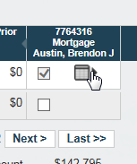

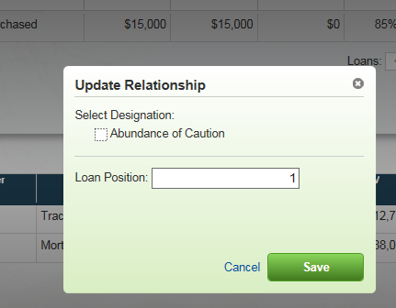

The ability to edit loan position on the Collateral Analysis screen is not available in all other ACAs.

